Dr. Michael Ashenhurst & Dr. Vivian Hill
Eye Physicians & Surgeons
Phone: 403 245 0112 Fax: 403 228 4038 email: ashen11@telus.net
Rebecca Mathias (Surgical Booking)

Your surgery location is: Southern Alberta Eye Center
Third Floor
5340 – 1st Street SW
(See next page for map)

Your follow-up appointments are all at the 17th Avenue office unless otherwise specified.

Your surgery dates and times are:

First Eye (________): _____________________ at ____________at the surgical site
Next day follow up: _____________________ at ____________at the 17th Ave office
One week follow up: _____________________at ____________at the 17th Ave office

Second Eye: _____________________ at ____________at the surgical site
Next day follow up: _____________________ at ____________at the 17th Ave office
One week follow up: _____________________ at ____________at the 17th Ave office

*** We will call/email you one week prior to your surgery to confirm your arrival time. ***

A final visit, for a glasses prescription, should be at 3 to 6 weeks, after your second eye has been completed. This appointment should be made with your optometrist unless otherwise specified.

- These appointment dates and times are sometimes subject to change due to emergencies or cancellations.
- Please have nothing to eat after midnight the night before your surgery. Clear fluids are OK up to 3 hours prior to your surgery. Then nothing.
- Start all 3 eye drops the day before surgery. Just in the eye we are operating on.
- If you wish to cancel or postpone your surgery, please notify the office at 403-245-0112 as soon as possible. We require one weeks’ notice to rebook/cancel.
- Patients who “No Show” for surgery, or don’t give the appropriate notice, should expect to pay a rebooking fee of $500 if they wish to reschedule. No Shows inconvenience everyone and delay needed surgery for other patients.
- DO continue taking all of your regular medications, especially blood pressure medications. Do take blood thinners but please advise us of these.
- Wear loose comfortable clothing.
- Please do not wear any make-up for your surgery day.
- You MUST have a responsible adult accompany you to and from your surgery. If not, the surgery will be cancelled and a no show fee will apply. Do not drive the day of surgery. If you don’t have anyone who is able to get you then you may use Driving Miss Daisy, Keys Please, or Ride Please.
- You may drive the following day if you are comfortable with your level of vision.

Southern Alberta Eye Center
Third Floor, 5340, 1st ST SW, Calgary, AB, T2H 0C8

The easiest way to get to the surgical center is to turn East onto 53rd Avenue SW off of Macleod trail. Follow this road to the end and you will come to a T-junction. The building is white and says the Southern Alberta Eye Center at the top. Paid parking is located at the back of the building. Please proceed to the third floor to check in.

INFORMATION FOR CATARACT SURGERY----BASIC EYE ANATOMY:

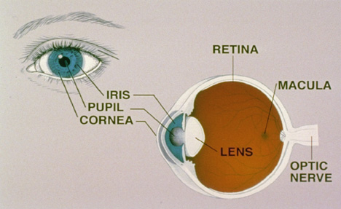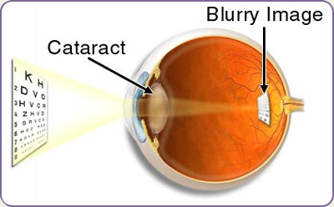

WHAT IS A CATARACT?
When the natural lens of the eye loses its usual transparency; this is called a cataract. Cataracts cause blurring of vision, distortion and glare. Cataracts can also change your eyeglass prescription. New glasses may temporarily help the vision in patients with cataracts.

Common symptoms of a cataract:
- Painless blurring of vision
- Glare and light sensitivity
- Poor night vision…especially driving
- Doubling of vision in one eye
- Fading or yellowing of colors
- Needing brighter light to read

A cataract is not:
- A film over the eye
- Spread from one eye to the other
- Caused by overusing the eyes
- A cause of irreversible blindness

The lens of your eye functions very much like the lens in a camera and focuses incoming light rays onto the retina. The lens is contained in a very thin membranous bag called the capsule. The capsule is held in place by tiny filaments called the zonules. The retina acts much like a film in a camera by gathering the visual information and sending it to the brain. The lens must be clear and have the correct power to focus images on the retina.

WHAT CAUSES CATARACTS?
Cataract formation is part of the normal aging process. The formation of cataracts may be accelerated by factors such as ultraviolet light exposure, smoking, laser eye surgery, diabetes and steroid containing medications. Sometimes infants are born with cataracts called “congenital cataracts”. Trauma to the eye can also cause a cataract in a previously normal eye. There is no current medical therapy such as eye drops or diets available to prevent or treat cataracts. Fortunately, cataract surgery has a high success rate.

WHEN SHOULD CATARACTS BE REMOVED?
The decision to remove cataracts is made when the blurring becomes significantly symptomatic and when surgery would be expected to improve the vision.

Based on your symptoms you and your ophthalmologist should decide together when surgery is appropriate. It is not true that cataracts need to be “ripe” before they can be removed. Cataract surgery can be performed when your visual needs require it. Sometimes it is medically necessary to remove cataracts for the overall health of your eyes. You must decide if you can see well enough to do your job, enjoy hobbies and activities, drive safely*, read or watch TV in comfort.

*Driving standards exist as to the MINIMUM visual acuity required (20/40 in one eye), but you may not feel comfortable driving even if you have this vision.

HOW IS CATARACT SURGERY PERFORMED?
Cataract surgery is usually done as an outpatient procedure at a surgical clinic under topical anesthetic (drops). You must be able to co-operate fully with your surgeon during the procedure if topical anesthetic is used. Please request a local needle anesthetic if you feel you will be unable to hold your eye steady, relax your eyelids open or are very nervous about your eyes and the procedure.

Dilating eye drops are placed in the eye by a technician approximately ½ hour before the surgery. Using a microscope for magnification, a small hole is made in the eye and an ultrasound probe is used to break up the cataract into tiny fragments. These fragments are then vacuumed out of the eye leaving behind the thin clear lens capsule. An artificial intraocular lens implant (IOL) is then placed in the capsule.

REFRACTIVE ERRORS:
A refractive error means that the eye does not focus light sharply on the retina and the image that is seen is blurred. Refractive errors include myopia “near-sighted”, hyperopia “far-sighted” and astigmatism (Warping of the corneal surface). Refractive errors are treated with either glasses, contact lenses, corneal or implant surgery.

EYE MEASURMENTS
There are two ways to measure eyes for IOL power, ultrasound (A-scan), and laser (IOL Master). We sometimes need to perform and compare both these methods for the most accurate results possible. The accuracy of both tests is affected by patient co-operation.

Eye measurements will take about an hour. Your co-operation is essential to obtain accurate measurements. The IOL Master uses advanced laser technology to precisely measure the eye prior to cataract surgery.

Previous refractive surgery such as Lasik, RK or PRK can seriously affect the measurements for implants.
Please let us know if you have ever had this type of refractive surgery.

Contact lenses cannot be worn for testing. If you use hard/gas permeable lenses, these need to be removed for one week before testing to gain accurate readings. Soft lenses need to be removed 24 hours prior.

HOW DO WE SELECT LENS IMPLANTS (IOLS)?

Standard IOL’s
These are designed to correct vision at ONE distance. Simple myopia and hyperopia can be corrected with standard IOL’s. Using present technology we are able to reliably achieve this goal within one diopter 95% of the time.
Usually focus for distance vision is chosen and reading glasses are worn when needed. Sometimes focus for near is chosen and distance glasses are worn. The lenses covered by Alberta Health are high quality injectable lenses. These lenses do not correct all postoperative refractive concerns.

Premium Lens calculations
Premium IOL’s offer more post-operative refractive options as outlined below. The costs of these lenses vary according to the manufacturer and clinic providing the implant. Alberta Health Care funds the cost of the standard high quality foldable IOL and will credit this amount to you if you select a premium IOL (we have already subtracted this amount from the prices). Unfortunately for non-Albertan’s, some other provinces do not even cover the cost of a foldable IOL and patients are required to pay for these. There is no GST for IOL implants.

With all upgraded lenses, there are extra charges involved above the cost of the lenses. These charges cover preoperative patient counselling, corneal mapping, corneal vector assessment, administration fees, online calculations, pre-operative markings, and intra-operative adjustments, as well as postoperative presbyopia management. We have included the charges in all lens prices below.

Alcon® Toric™ Lenses
Corneal astigmatism is a condition where the cornea is warped causing blurring of vision.
Standard IOL’s do not correct corneal astigmatism. Toric™ IOL’s may be implanted at the time of routine cataract surgery instead of the standard IOL. Presently Alberta Health Care does not cover the cost of this lens and the additional assessment. Simple reading glasses will still be required.

Toric™ lenses are designed to reduce astigmatism significantly BUT may not ELIMINATE all astigmatism.
You will not benefit from a Toric™ lens if you do not have astigmatism. If you have a scarred or thinned cornea the Toric™ lens may not help your vision as much.

The cost of these lenses is $948.50 for one eye and $1,897 for two eyes.

Alcon® PanOptix ™ Trifocal lens
The Alcon® PanOptix ™ is a new Trifocal lens, providing correction for near (20cm), intermediate (40cm), and distance (100cm+). It was designed to create higher clarity of correction at functional distances without glasses. Eg. Looking at your phone, reading a book, working on the computer, or watching TV.
However, no guarantee can be made and you may still require reading glasses for fine print. We find this lens is clearer for near vision, such as using a cell phone.
There can be some halos around lights at night, specifically when driving. This can take around 6 months to settle, but will never completely go away.
This lens also has a Toric counterpart to correct astigmatism.

Alcon® PanOptix ™ is $1,827.50 for one eye and $3,655 for two eyes.

Alcon® PanOptix Toric™ is $2,032.50 for one eye and $4,065 for two eyes.
Bausch + Lomb Finevision ™ Trifocal lens
The Bausch + Lomb is another trifocal lens correcting for distance, intermediate, and near vision. It features a patented innovative trifocal structure designed to significantly improve performance for intermediate vision.
We find this lens is better suited for patient who use computers regularly.
There can be some halos around lights that can take a few months to settle down, but these will never completely go away.
You may need reading glasses for fine print after surgery.

Bausch + Lomb Finevision™ is $1,527.50 for one eye and $3,055 for two eyes

Bausch + Lomb Finevision Toric™ is $1,707.50 for one eye and $3,415 for two eyes

Payments of lenses are due at least two weeks in advance. We accept payment through Visa and Mastercard (credit card payments carry a 2% transaction fee), Debit, Cash, and certified cheque.

COMPLICATIONS
As with any kind of surgery, there are RISKS associated with this procedure. Fortunately, these are rare. The least common is loss of the eye.

Flomax™
Certain medications that reduce bladder neck spasm and help urination can have serious effects on the eye during cataract surgery. The most frequent offender is FLOMAX^{TM.} This medication causes poor pupil dilation and a floppy iris during surgery that can interfere with the surgeon’s ability to remove the cataract and significantly increase the likelihood of intraoperative complications. Please let us know if you are currently on this type of medication or if you have EVER taken it. Certain special precautions must be taken before and during the surgery.

Capsule Rupture
Rupture of the delicate capsule can occur in some eyes. This can result in the need for a second surgery and may make it impossible to implant the desired IOL.

Infection
Infection in the eye after surgery can be the most serious complication and can result in total blindness and loss of the eye. (0.1% risk) Symptoms include pain and increasingly blurry vision. The most common time to develop an infection is between 2 and 7 days after surgery. Infections are treatable in most cases but MUST be brought to our attention RIGHT AWAY for the best possible outcome.

Refractive errors:
Despite our best efforts significant myopia, hyperopia or astigmatism may exist following cataract surgery. This may be corrected with glasses, contact lenses, and refractive surgery or may require IOL exchange. Differences in the post-operative lens power between both eyes may be particularly difficult to tolerate even with glasses and may require IOL exchange. IOL exchange is a separate surgical procedure and carries with it significant risks.

Double vision:
Cataract surgery may cause temporary double vision (around 10% of people will get this). In less than 1% of cases double vision will be permanent. It may then require prism glasses or muscle surgery to correct the double vision. Anesthesia with topical drops/gels rather than a needle is much less likely to cause double vision

Corneal swelling
Corneal swelling and astigmatism can reduce vision after surgery. The swelling is usually temporary (lasting several days up to several weeks) but some people are prone to prolonged or permanent swelling.

Ptosis (droopy eyelid):
The upper eyelid has a delicate tendon that may be stretched as a result of any eye surgery. Patients who have previously weakened this muscle by minor injury such as prolonged contact lens wear may be at increased risk. Postoperative ptosis will sometimes improve spontaneously but often requires an eyelid “tuck” procedure, which is performed under local anesthetic. Ptosis will occur in about 1% of patients.

Secondary cataract:
One of the most common complications is the formation of scar tissue on the capsule behind the artificial lens. This is called a “secondary” cataract and is sometimes referred to erroneously as the cataract “growing back”. A routine laser treatment called a “YAG Capsulotomy” easily treats this capsule opacification. This laser treatment is painless, quick and required in about 25% of patients. It carries with it a small risk of eye pressure rise and retinal detachment.

Pressure rises:
It is not unusual for the pressure in the eye to rise after surgery, resulting in some discomfort. This is usually temporary and may require medication on a short-term basis. Pressure problems are more frequent in patients with glaucoma or in patients who are prone to glaucoma.

Retinal disease:
Retinal detachment can be associated with cataract surgery and cause severe visual loss (1% risk). The symptoms of a retinal detachment are floating dots, flashing lights and a curtain of vision loss approaching from the outside into the central vision. Retinal detachment should be treated as soon as possible.

Retinal swelling may reduce vision after cataract surgery (macular edema). This may require additional tests on the eye, eye drops, oral medications or rarely injections of medication into or around the eye.

EYE DROPS

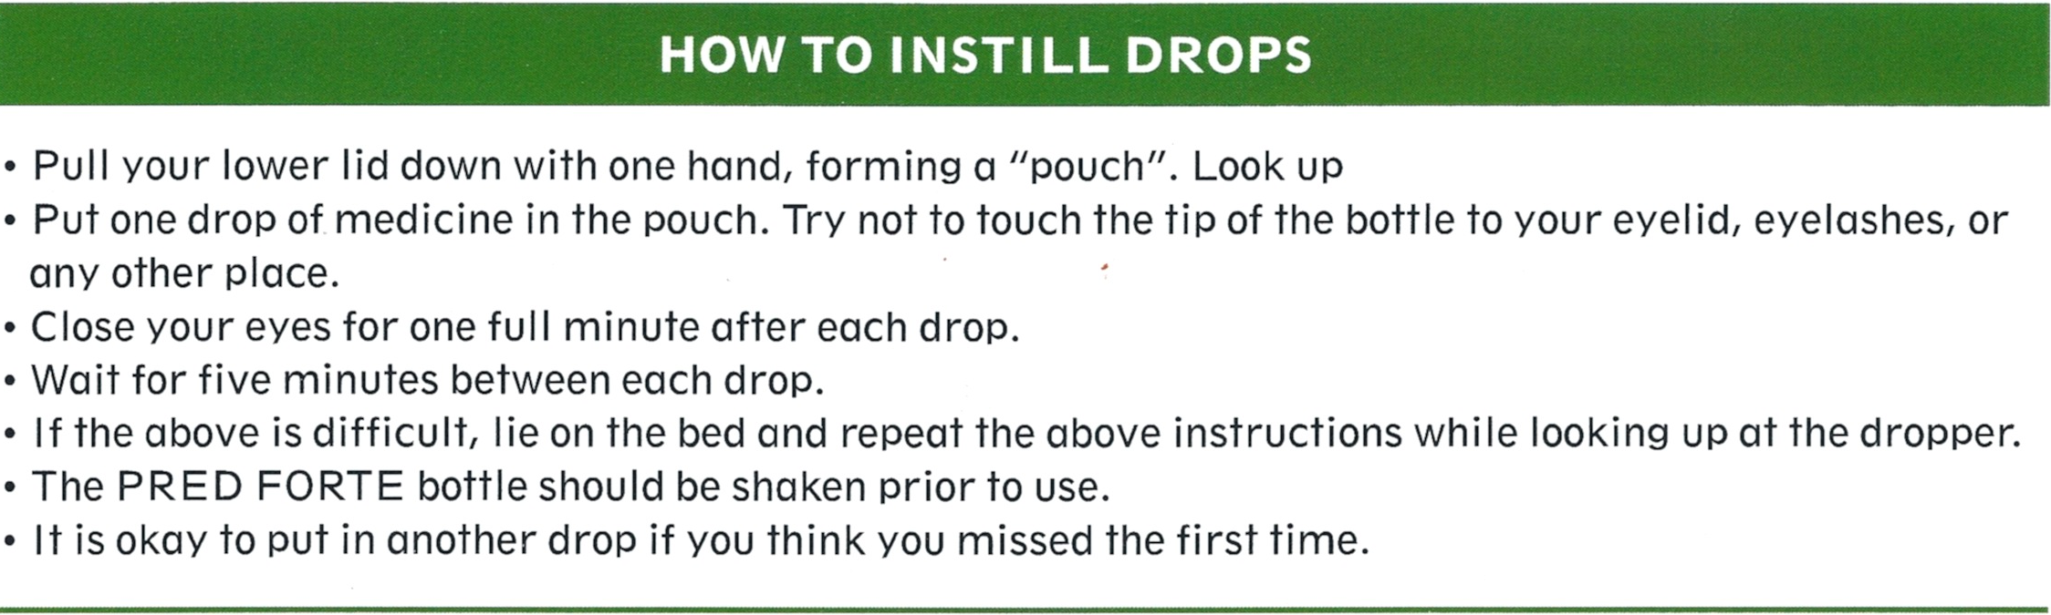
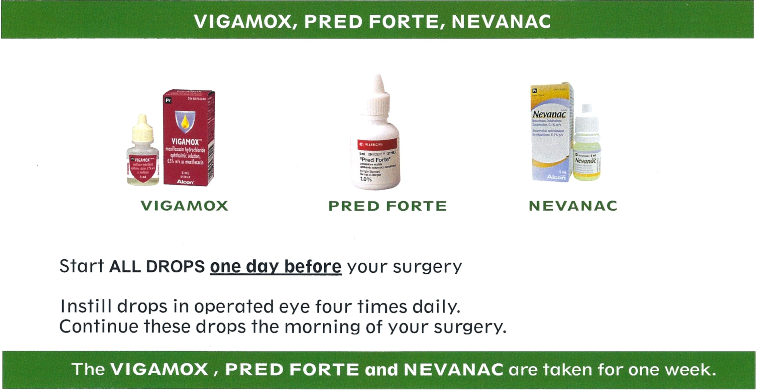
PRE-OPERATIVE DROPS
- Use all three drops (Vigamox/Nevenac/ Pred Forte) one drop of each, four times a day, the day prior to surgery in the eye to be operated on.
Wait 5 minutes between each drop.
POST-OPERATIVE DROPS
- On the day of your surgery, before you go to the surgical center, do one drop of each.
- When you get home after your surgery, Use the Vigamox EVERY HOUR until bedtime. Use the Pred Forte and Nevenac, one drop of each, four times on the day of surgery.
- The day after your surgery, (Usually Wednesday), use all three drops Vigamox/Nevenac/ Pred Forte four times a day. Wait 5 minutes between each drop. Continue Vigamox until the bottle is empty. The Pred Forte and Nevanac are used until otherwise ordered by your surgeon.
- Use extra drops if your eye is uncomfortable or if you think you may have missed the eye.
- Get a new set of drops for the second eye surgery (if applicable). You should have automatically been given refills on your prescription.

**It is very important to use your drops as prescribed. Failure to do so can lead to postoperative complications, including infection.**

- Do not rub your eye. Your incision is located under the upper lid.
- Take Tylenol for any mild discomfort.
- Avoid getting water in your eyes for 48 hours following surgery. Avoid swimming for least 1 week.
- Wear the plastic eye shield at night for 2-5 days to protect your eye. The shield may be applied using tape. This is to prevent poking or rubbing your eye while you sleep.
- Sunglasses may be worn when outdoors for comfort. They may also be worn indoors, as well, if your eyes are sensitive to bright room light. Do not lift anything heavy (>25-pounds, including pets and grandchildren) for 5 days.
- Moderate bending is permitted, however it is not recommended that you bend over for extended periods of time (no more than 10 minutes). Minimize physical activity for 5 days (tennis, bowling, curling, sex, golf, etc.)

WHAT IS NORMAL AFTER SURGERY?

- Some mild discomfort and blurring – use extra drops if this feels better
- Double vision especially after a patch comes off
- Haloes around lights
- Light sensitivity
- Scratchy eye…like you have a hair in it.
- Pink tears
- Bruising in or around the eye

WHAT IS NOT NORMAL AFTER SURGERY?

Fortunately, the more serious complications of cataract surgery are very rare:
- Persistent pain not relieved by eye drops
- Loss of vision
- Vomiting and/or nausea
- Persistent redness and discharge (pus)

If any of these occur within the first 12 days of your surgery, contact the office immediately during regular office hours at 403 245-0112 or after hours, Dr. Ashenhurst can be reached at (403) 390-5152

If you are unable to get in touch with your surgeon you may also call the HealthLink at 811. Only proceed to the emergency room at Rockyview only if you are unable to get in touch with anyone.

RESCHEDULING/CANCELLING

If you need to cancel or reschedule your surgery, we need at least one week’s notice. If you do not provide one week’s notice there will be a rebooking fee of $500. Exceptions are made for emergency situations with supporting documentation. Please call Surgical Booking at 403 245 0112 as soon as you can if you need to change/cancel your surgical date(s).

